Bacti-cinerator Sterilizer——IS800-A
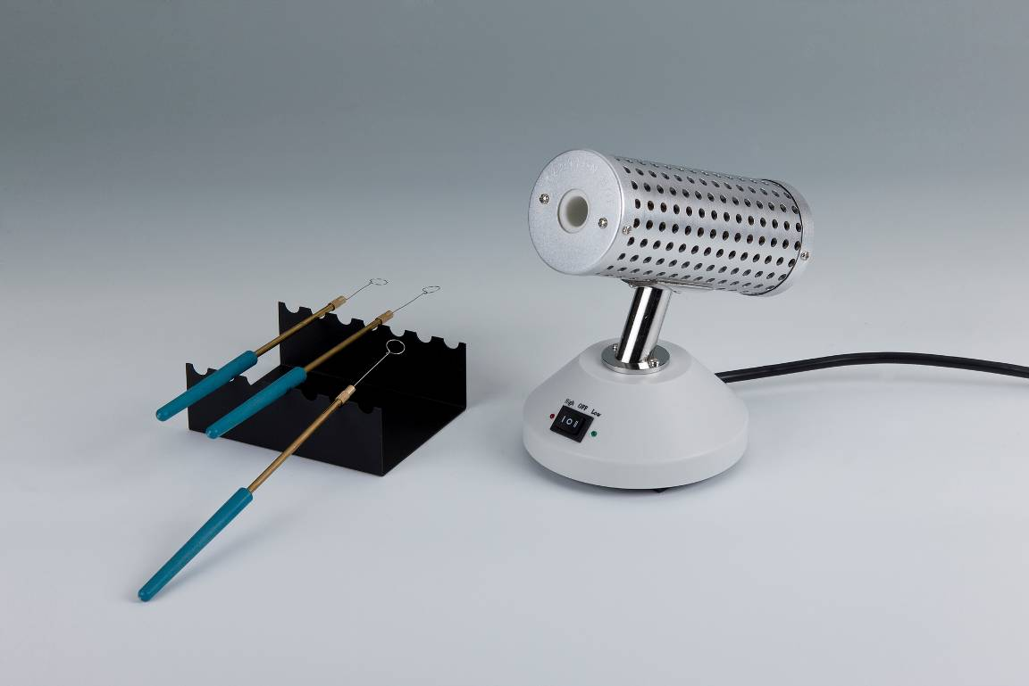
Description:
IS800-A Bacti-cinerator Sterilizer is used in degassing for inoculating loops and needles, instead of alcohol lamps. Due to its convenience, sterilizer is widely used in the environment of biosafety cabinets, clean benches. They are also used besides exhaust fans or on mobile vans.

Features:
- Safety, convenient. Totally take the place of alcohol lamps.
- Only 5 seconds to 7 seconds are needed, because of its highest temperature of 825℃.
- Smart, light, easy to handle.
- Used in anaerobic chamber is allowed.
- Podzolic organics prevent pollutions effectively.
- Smart technique makes it possible to use for a long time and much safer.

Application:
Widely used in biosafety cabinets, clean bench, near exhaust fan, mobile vehicles, even outdoor and othere severe environment can be easily used.

Parameters:
Type  Parameter | IS800-A
Max. temp. in central zone | 825℃±25℃
Max. outer diameter of sterilization goods | Φ15mm
Length of heating zone | 140mm
Heating time | 15min
Ambient temperature | 5℃～40℃
Fuse | 250V 3A Φ5×20
Voltage | AC220V or AC110V, 50-60Hz
Power | 150W
Dimension(mm) | 120×155×180
Weight(kg) | 1.0

